After playing the game of chess with the same rules for such a long time grandmaster Anand decided to make the game more interesting. He decided to grant the queen additional power where-in it can now also move like a knight & he named this new piece as Ninja. For illustration consider the below diagram which shows all the squares a ninja piece located at e4 can attack, here the crosses represent the squares which can be attacked by queen like moves while circles represent squares which can be attacked by knight like moves.

You have been given a diagram of the chess board with only three pieces left on the board: a white ninja, the white king, and the black king. It's black's turn to make move. You would like to determine whether the chess game is over or not. Unfortunately, the diagram is not very clear and you can't figure out the square on which the black king is located, so you decided to consider all possible squares on which the black king could be located.

You are given the squares on which the white pieces are located on a standard chessboard. Your task is to determine the number of possible black king's positions such that:

it's checkmate (i.e. black's king is under attack from ninja's attack and it cannot make a valid move);

it's check (i.e. black's king is under the ninja's attack but it can reach a safe square in one move);

it's stalemate (i.e. black's king is not under attack but it cannot make a valid move);

black's king is not under attack and it can make a valid move.

Note that two kings cannot on two adjacent squares including diagonally adjacent ones.

Example

For king = "d3" and ninja = "e4", the output should be

ninjaChess(king, ninja) = [5, 21, 0, 29].

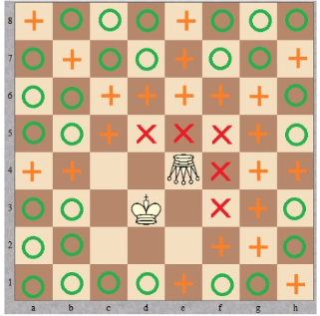

Red crosses correspond to the checkmate positions, orange pluses refer to check positions, and green circles denote safe squares.

For king = "a1" and ninja = "g5", the output should be

ninjaChess(king, ninja) = [0, 29, 1, 29].

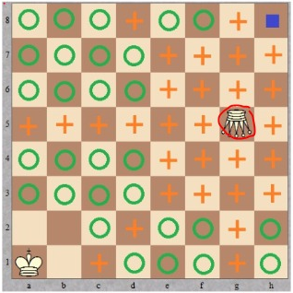

The stalemate position is marked by a blue square.

An array of four integers, each equal to the number of black's king positions corresponding to a specific situation. More specifically, the array should be of the form [checkmate positions, check positions, stalemate positions, safe positions].